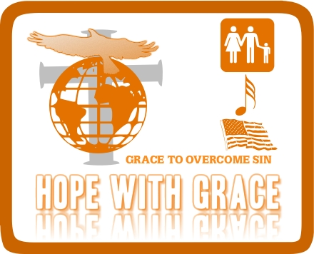
THE TALE OF BARRENNESS
B A R R E N N E S S

Best Awaiting Resolutions, Real Enough, Needing Necessary Eternal Supreme Sovereignty.
Barrenness implies a bad – nature or state of abnormal wellbeing. It does not mean that all hope is lost or that we can’t make it again. The current world is now a habitation for barrenness caused by the mistakes of the generations past even if we can’t recall any, based our family or background’s past due to the fact that we are not yet born then, at least we can still consult Genesis 3:1-24 (The fall of man from the Garden of Eden).
But for a child of God (the Lord chosen) in most cases, barrenness is the preservation for the best, to show God’s supremacy Genesis 11:30. Sometimes barrenness is attributed to a land of poor facilitation for the goodness that awaits.
In Genesis 12:1-3, God told Abraham to move away from the environment that lays barrenness, for the greatness God wanted to do. Little did he know that God was actually working His way to break the abnormality in his life (the land he dwells). So also, we are experiencing barrenness is some areas of our lives today even when we don’t know, so many are incapacitated resourcefully via this attribute barrenness that has crept into the world system, making things that are abnormal to look normal and vice versa.
Also in Matthew 21:1-5, an ass was laid barren for a certain period of time by been tied just for it to be made glory as it has been written according to the verse 5. During the time it was tied, it was barren because it could not perform it function of carrying man, rendering it completely useless until the appointed time.
The truth is that, a challenge in your life is barrenness, and no one on this earth can claim to be free from challenges except those who are dead and those whom God has made. But before they are made, they are once barren one way or the other because of one challenge or the other. It is not a crime to be barren but it is stupidity to die been barren whether spiritually, physically, morally, financially, maritally, socially e.t.c. because if God wanted that, Jesus would not have come to the earth to give us victory over all forms of barrenness.
In Genesis 17:1-21, why did you think God emphasis on the birth of Isaac through Sarah? Despite the fact that Abraham has consented to Sarah’s advice to sleep with Haggai who gave birth to Ishmael, It is because the Lord has chosen Sarah and Whosoever the Lord has chosen cannot die barren. Just like Sarah we are chosen, no matter what we are going through even when it deviates from normalcy in terms of man’s understanding, knowledge and wisdom. Let us always remember one fact that “nothing is impossible for God to do” for those who truly trust, believe, have faith, waiting on and living God’s Word. Nobody would believe that Sarah could give birth at that age but she did, nobody would believe that the ass that carried Jesus will carry Him because he was kept where no man can think of, but it did carry Jesus.
The only case whereby a woman died without a child in the bible was that of Michal the daughter of Saul (David’s wife) who actually despised David in her heart because He gave honour to the Lord via leaping and dancing before his people to exalt God (2 Samuel 6:16). Please never exalt man above God because who is man before God the creator of all things.
One thing that I’m sure of, God cares very much about man (God’s chosen) and his seeds (spiritually, physically, morally, financially, maritally, socially e.t.c.) John 3:16, He doesn’t just give man a seed, but a great seed or let me say the best seed.
For that to happen, for barrenness to be broken, the following must be in place
- A right environment has to be put in place. Why did you think Mary was chosen by God to give birth to our Lord Jesus Christ? It is simply because She kept are body and bed undefiled despite the fact that she has already a fiancé (Joseph) yet they understood heavenly order concerning marriage, that God could look for no other virgin except her. For us today the right environment that needs to be in place is genuine salvation. We need to genuinely surrender our lives to Jesus and love Him. Remember we can’t claim to love Jesus without doing what he expect of us. This is, to be perfect like our father in Heaven, to flee from every form of evil (no more sin). John 3:16, John 14:13-20
- The word of God: We need to allow God’s word to live in us. Gen. 12:1-3, Mat. 1:18-25, Mat. 21:2-3, Mat. 8:8-13, Exo. 3:5
- Obedience to God’s word and those God has placed to help us. Mat. 21:6-9
- Having Faith totally without any slight disbelieve
Prayer Point
- Lord Jesus place me in the right environment for me to be fruitfully (specify the area we know we still have issue). Lord Jesus I totally surrender my life to you.
- Send Your word to me Lord, Please speak to my life Jesus
- When your word comes Lord fill me with the Holy Spirit which the Spirit of obedience and faith, that I will obey, believe and do accordingly to Your word.
Thank you for your time and remain blessed.

